Greetings,

We welcome you to come stay and experience our outstanding hospitality! Located off I-69, Exit 311B (Old 111B), the BEST WESTERN PLUS Fort Wayne Inn & Suites North is the place to stay if you are after friendly service and comfortable accommodations.
Renovations have been completed as of 2014

Exceptional service puts our beautiful hotel above the rest. Featuring an indoor heated pool, whirlpool and fitness center, there is no better place to relax. Stay connected with complimentary hotel-wide Wi-Fi Internet access. The complimentary breakfast ($9.00 value) sweetens the deal. Dig into platefuls of sizzling hot eggs and waffles, sausage, biscuits and gravy, fresh fruits and sweet pastries, hot and cold cereals, yogurt, chilled juices and 100 percent Arabica coffee.
Status Match… No Catch® offer is open to new and existing Best Western Rewards® members. For those that wish to upgrade their current or new Best Western Rewards status level equal to, but not higher than, their current elite status level in any other competing hotel chain’s loyalty program. Bonus points to the organizations for each stay through our Best Western Rewards® program are also available.

Each newly remodeled guest room has amenities such as wireless/wired Internet, microwave, refrigerator. pillow-top beds, and 40-inch LED televisions. A warm welcoming staff and top notch, renovated rooms await you at our inviting hotel. Welcome to your home away from home!

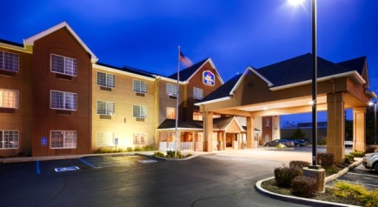

Warmest Regards,

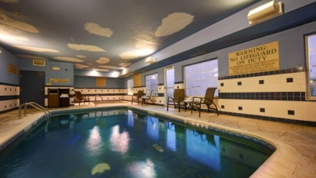
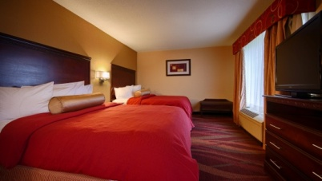
Terria Justice
Sales Director
(P)260-490-6060
(F)260-490-5050

